S.T.A.R.S. Autonomous Charging System
System Requirements Specification
Version 1.0
09/30/2025

Total (100%)

Document Control

Distribution List
The following list of people will receive a copy of this document every time a new version of this document becomes available:
Teaching assistants:
Rajagopal Sugumar
Sakurako Kuba
Jose Alejandro Gonzalez Nunez
Casey Elder
Customer(s): Dr. Bryan Watson, Jonah Kohlmeyer, BID4R Lab
Project team members:
Evan Giordano
Josh Radjavitch
John Ferguson

Change Summary
The following table details changes made between versions of this document:
Version | Date | Modifier | Description
1.0 | 09/30/2025 | John Ferguson, Josh Radjavitch, Evan Giordano | The initial version of the SRS consisting of initial requirements, diagrams (high level) and use case is started.  We include the hardware being used for the charging station parts specifically we need for QI wireless charging for the swarm robots.
1.1 | 10/07/2025 | John Ferguson, Josh Radjavitch, Evan Giordano | Sections 1, 2 and 3 are completed, pending modifications from other team members.
1.2 | 10/14/2025 | John Ferguson, Josh Radjavitch, Evan Giordano | Sections 4, 5 and 6 are completed, pending modifications from other team members. Changes to sections 1, 2, and 3 are implemented as well.
1.2.1 | 10/18/2025 | John Ferguson, Josh Radjavitch, Evan Giordano | Section 8 is completed, SRS document sent into customer & TA for feedback for team to use in editing before submission.
1.3 | 10/19/2025 | John Ferguson, Josh Radjavitch, Evan Giordano | All sections are completed, feedback from all team members and TA Raj is implemented, ready for v1.0 submission.

Table of Contents

Document Control 1
Distribution List 2
Change Summary 2
1. Introduction 3
1.1. Purpose and Scope 4
1.2. Intended Audience and Reading Suggestions 4
1.3. Document Conventions 4
1.4. Project References 4
1.5. Definitions, Acronyms, and Abbreviations 5
1.5.1. Definitions 5
1.5.2. Acronyms 5
1.5.3. Abbreviations 5
2. General Description 5
2.1. Product Perspective 6
2.2. Product Features 6
2.3. User Classes and Characteristics 6
2.3.1. Actors 7
2.3.2. Use Cases 7
2.3.3. Scenarios 8
2.4. General Constraints 8
2.5. Operating Environment 9
2.6. User Documentation 9
2.7. Assumptions and Dependencies 9
3. External Interface Requirements 9
3.1. User Interfaces 10
3.1.1. Mobile User Interface 10
3.2. Hardware Interfaces 12
3.3. Software Interfaces 12
3.4. Communications Interfaces 12
4. Behavioral Requirements 13
3.1. Same Class of User 14
3.2. Related Real-world Objects 14
3.3. Stimulus 14
3.3.1. Mobile App Stimulus 15
3.4. Related Features 15
3.5. Functional 15
5. Non-behavioral Requirements 16
5.1. Performance Requirements 17
5.2. Safety Requirements 17
5.3. Qualitative Requirements 17
5.3.1. Availability 17
5.3.2. Security 18
5.3.3. Maintainability 18
5.3.4. Portability 18
5.4. Design and Implementation Constraints 18
6. Other Requirements 19
6.1. Database Requirements 20
6.2. Operations 20
7. Analysis Models 20
7.1. Data Flow Model 21
7.1.1. Data Sources 21
7.1.2. Data Sinks 21
7.1.3. Data Dictionary 21
7.1.4. Context Diagram (Level 0 Data Flow Diagram) 22
7.1.5. Level 1 Data Flow Diagram 22
7.1.6. Level 2 Data Flow Diagram 23
7.2. Class Model 23
7.3. State Model 24
8. Impact Analysis 25

Introduction (7%)

Purpose and Scope
The purpose of the System Requirements Specification (SRS) document is to describe the requirements and functionality of the S.T.A.R.S. Autonomous Charging System for an Embry-Riddle Electrical Engineering and Computer Science Capstone Project, partnering with the BID4R Laboratory, which is led by Dr. Bryan Watson. The scope of the project is to develop an autonomous charging system, capable of charging and powering a swarm of 50 robots for 24 hours of continuous functionality. This is a subsystem of the STARS project, which is being developed as the largest wheeled robot swarm in academia. This charging system is being produced to enable these robots to function for the full 24 hours without any human interaction.
The products that will be produced within this project is a charging receiver on all 50 robots, as well as 10 transmitters spread across the swarm arena. The robots will be able to drive up to a charger, which will be outlined like that of a parking spot, and sit there to charge when necessary. There will be five robots assigned to each charger initially and then will evolve to dynamic queuing with five bots using 10 total chargers for 50 total bots. Robots will be able to queue into their specific charger and the first robot that is in the queue will be able to ‘park’ into the spot and charge until it is no longer necessary.
The scope of this project contains a system of 10 wireless chargers, being called the Autonomous Charging System, for a swarm of 50 bots, which will be designed like parking spaces within the swarm’s arena. A queuing algorithm will also be designed to allow swarmbots to queue into any charging station without any human interaction. Out of scope for this project is the ability for swarmbots to charge during normal operation, as well as designing more than 10 stations for the robots and planning for there to be more than 50 swarmbots. The transmitters and receivers have already been provided to the team, so those will also not be modified, so the charging speed relies entirely on their vicinity to each other.

Intended Audience and Reading Suggestions
This document is intended to be used as a reference for the developers of the system, as developers will constantly refer to this document to ensure the system meets all requirements, and different diagrams and components will be modified as needed. In addition, this document will be used by both the customers and the instructors/TAs for the Senior Design class, so they can ensure that what the team is doing aligns with the customer’s requirements and goals.

Document Conventions
There are no specified document conventions followed for this document.

Project References
BID4R Lab. (2025). Swarm Test Arena for Resilient Systems (STARS): Ongoing and upcoming work. BID4R Lab.
Capuano, J., Pallen, A., Gratton, G., & Watson, B. (2024). Implementation of a turtle-based consensus algorithm on drone swarm search & rescue. BID4R Lab.
Gorthey, J., & Watson, B. (2024). Biologically inspired resource allocation for distributed multi-agent systems with limited knowledge. BID4R Lab.
Wira, J. C., Nanjamma, S., & Watson, B. (2024). Sandpiper food search algorithm: A new optimization approach for agents with limited knowledge. BID4R Lab.
Wira, J. C., Nanjamma, S., & Watson, B. (2024). Sandpiper food search algorithm (SFSA). BID4R Lab.
Scheinblum-Brewer, M., & Watson, B. (2025). Validating a bio-inspired swarm platform through boids: A comparative analysis of simulation and physical behavior. BID4R Lab.
Neubert, A., & Watson, B. (2025). Interplanetary colonization with multi-agent systems: A systematized literature review. BID4R Lab.
Kohlmeyer, J. (2025). STARS autonomous charging system: Capstone proposal. BID4R Lab, Embry-Riddle Aeronautical University.
International Organization for Standardization. (2014, February). ISO 13482:2014 Robots and robotic devices — Safety requirements for personal care robots (ISO Standard No. 13482:2014). https://www.iso.org/standard/53820.html
National Fire Protection Association. (2020). NFPA 855: Standard for the installation of stationary energy storage systems. NFPA. https://www.nfpa.org/855
Institute of Electrical and Electronics Engineers. (2017). IEEE standard for software life cycle processes (IEEE Std 12207-2017). IEEE. https://doi.org/10.1109/IEEESTD.2017.8016712
Institute of Electrical and Electronics Engineers. (2016). IEEE standard for system, software, and hardware verification and validation (IEEE Std 1012-2016). IEEE. https://doi.org/10.1109/IEEESTD.2016.7473039
Institute of Electrical and Electronics Engineers. (2016). IEEE standard for verification and validation of hardware elements of digital systems in safety systems (IEEE Std 1201-2016). IEEE. https://doi.org/10.1109/IEEESTD.2016.7473028
Kale, R. R. (2025). Development of a robotic swarm test arena for multi-agent resilient systems (Graduate research project, Embry-Riddle Aeronautical University).

Definitions, Acronyms, and Abbreviations

Definitions
This section lists terms used in this document and their associated definitions.
Table 1: Definitions
Term | Definition
Total impulse | A measure of the overall total energy contained in a rocket motor

Acronyms
This section lists the acronyms used in this document and their associated definitions.
Table 2: Acronyms
Term | Definition
SDD | System Design Document
AI | Artificial Intelligence
API | Application Programming Interface
BID4R | Biologically Inspired Design for Resilient Robotics
EEPROM | Electrically Erasable Programmable Read-Only Memory
GUI | Graphical User Interface
IDE | Integrated Development Environment
IEEE | Institute of Electrical and Electronics Engineers
I2C | Inter-Integrated Circuit
SPI | Serial Peripheral Interface
IoT | Internet of Things
ISO | International Organization for Standardization
JST | Japan Solderless Terminal
LiPo | Lithium Polymer
MAS | Multi-Agent System
MCU | Microcontroller Unit
MQTT | Message Queuing Telemetry Transport
NAS | Network Attached Storage
NFPA | National Fire Protection Association
OSHA | Occupational Safety and Health Administration
POI | Point of Intertest
RGB | Reg, Green, Blue
RTOS | Real-Time Operating System
SFSA | Sandpiper Food Search Algorithm
S.T.A.R.S. | Swarm Test Arena for Resilient Systems
UART | Universal Asynchronous Receiver-Transmitter
UAV | Unmanned Aerial Vehicle
V&V | Verification and Validation

Abbreviations
This section lists the abbreviations used in this document and their associated definitions.
Table 3: Abbreviations
Term | Definition
Rx | Receiver
Tx | Transmitter
W | Watt(s)
V | Volt(s)
DC | Direct Current

General Description (15%)

Product Perspective
The S.T.A.R.S Autonomous Charging System is a charging system that will be able to charge multiple swarm robots for the purpose of maintaining operation for an extended period of time. The BID4R lab is making a robotic swarm that will be capable of performing verification of biologically inspired algorithms. The senior design group working on this project oversees the design of the charging stations that are crucial to the operation of multiple robotic swarm bots. Since these swarm robots have already been designed and constructed, the senior design group will also have the responsibility of designing a mount for a receiver that will be connected to each swarm bot. The designs for the receiver mount and charging station will work together to achieve the overarching goal of supplying each of the robotic swarm robots with the resources needed to maintain battery charge and stay operational.

Product Features

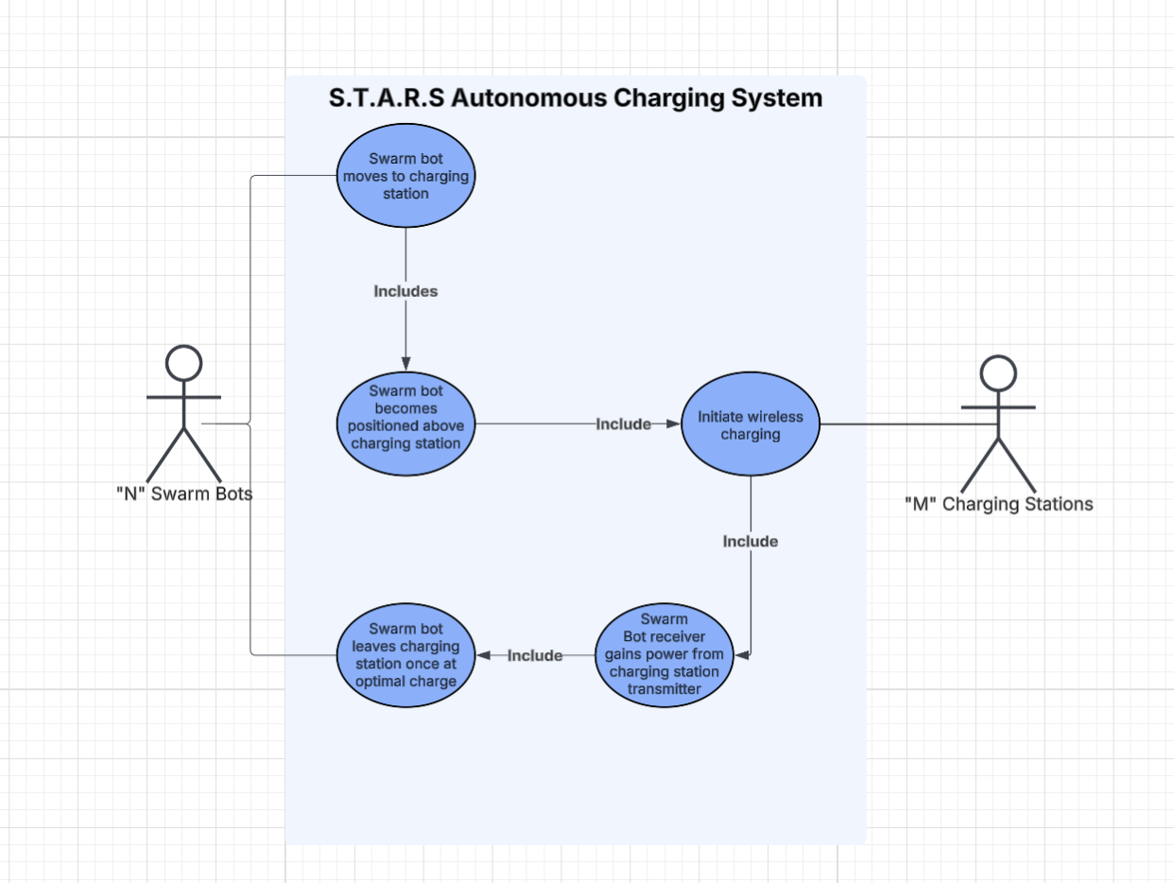

User Classes and Characteristics

Actors
This section presents the actors in the system.
- “M” Charging stations
  - A static charging station that is located inside of the arena. The “N” means an unspecified amount, since due to the nature of the project there will be changes to the amount of stations that are placed inside the arena.
- “N” Robotic Swarm Bots
  - A robotic swarm bot with the capability to move around the arena and perform various tasks including but not limited to moving to a charging station and initiating a connection to start charging the battery. The “N” means an unspecified amount, since due to the nature of the project there will be changes to the amount of swarm robots placed inside the arena.

Use Cases
This section presents the Use Cases, developed for the system.
- Swarm Bot moves to a charging station
  - One swarm bot moves to a charging station and positions itself in operational range above the transmitter.
- Swarm bot becomes positioned above charging station
  - One swarm bot becomes positioned above the charging station and is eligible to receive charge.
- Initiate wireless charging
  - Once a swarm bot is eligible to receive charge, the charging station transmitter gives off power that is taken in to the receiver on the swarm unit.
- Swarm bot receiver gains power from the charging station transmitter
  - Once wireless charging is initiated, the swarm bot gains charge and the battery charge percentage rises.
- Swarm bot leaves charging station once at optimal charge
  - Once a swarm bot is at the upper limit of operational battery charge, or optimal charge, the swarm bot leaves the charging station.

Scenarios/ConOps
Scenario 1: Swarm Units choose which bot will have the highest priority to charge
Description: The swarm robots decide which unit shall be placed first in queue, then second, and so on and so forth.
Actors: “N” Swarm units. The amount “N” Represents will be scaled as the project continues.
Precondition: The charging stations and swarm units have been placed in the arena.
Trigger Condition: The swarm unit(s) fall below the lower limit of operational battery range decided after testing.
Steps:
- The swarm bot(s) fall below operational battery range.
- The swarm bot(s) with the lowest battery becomes selected by the swarm to have the highest priority to charge
Scenario 2: Highest priority swarm unit moves to charging station
Description: The swarm bot with the highest priority in the charging queue moves to the location of the charging station
Actors: “N” Swarm units. The amount “N” Represents will be scaled as the project continues.
Precondition: The charging stations and swarm units have been placed in the arena, and a charging priority queue has been created.
Trigger Condition: The charging priority queue has been created, and there is at least one swarm unit in the queue.
Steps:
- The swarm unit with the highest priority in the charging queue goes to charge.
- The swarm unit moves to the location where the charging station is positioned.
- Once at the charging station, the charging station status is set to in use.
- Once the charging station status is set to in use, the swarm unit is removed from the priority queue.
Scenario 3: The swarm unit finishes charging.
Description: The swarm unit reaches the upper limit of the operational battery range, and moves away from the charging station.
Actors: “N” Swarm units. The amount “N” Represents will be scaled as the project continues.
Precondition: A swarm unit is occupying a charging station and the upper limit of operational battery range is reached.
Trigger Condition: The upper limit of one swarm unit’s operational battery range is reached.
Steps:
- The swarm unit leaves the charging station, making sure not to collide with other swarm units.

General Constraints
There shall not be any human interaction with the robots once operation commences.
The swarm robots shall be contained in an 8x10 foot arena constructed of wood boards.
The system should attempt to maintain the operation of swarm robots for 24 hours.

Operating Environment
The swarm shall operate in the S125 laboratory. This environment contains an 8x10 foot wooden arena where the swarm robots will be operating in. The S125 laboratory also contains a camera on the ceiling above the arena.

User Documentation

As per the requirements of the project declared by Rasika Kale in the graduate research project document: “Development of a Robotic Swarm Test Arena for Multi-agent Resilient Systems”, there should be virtually no human interaction with the bots. Therefore, there are no user manuals, on-line help, or tutorials to be provided.

Assumptions and Dependencies
The senior design group working on the project: S.T.A.R.S Autonomous Charging System have made the following assumptions:
- No outside factors shall affect the operation of the swarm inside of the arena.
- The charging stations shall not be affected by any loss of power due to public infrastructure.
- The other portions of the system completed by other members of BID4R shall run without error.
- Work done during the first semester will be scaled for a larger number of swarm robots during semester two.

External Interface Requirements (10%)

User Interfaces(UI) (UIR – User Interfaces Requirements):
UIR 01 | The system shall generate the charged state in real-time with indicators from the RGB where BLUE = SEARCHING, GREEN = CHARGING, and RED = ERROR).
UIR 02 | The system shall utilize a manual reset for the MCU with a mounted button.
UIR 03 | The system shall not require the user UI for normal operations.

Mobile User Interface
N/A, this project is non-user interface operated.

Hardware Interfaces
The Arduino Nano 33 IoT Microcontroller the primary micro controller unit (MCU). All other protocol-based devices are interfaced with the MCU. The MCU connects I2C, SPI, and UART communication protocols. Pixy2 Camera Sensor which uses SPI, UART, and I2C.
- Arduino Nano 33 IoT Microcontroller - physical connector specifications (jumper wires, RJ45).
- Adafruit DRV8833 Motor Controller Breakout Board - communication protocol standard (I2C, SPI, Ethernet, custom protocol).
- Pixy2 Camera Sensor.
- Proximity Sensor.
- 5mm RGB Multicolor LEDs.
- DC/DC Boost Converter Adafruit 1000c Powerboost.
- LiPo Battery (3.7V, 3000mAh).
- Qi Wireless Charging Receiver Module (In: 5-9V, Out: ~5W)
- Qi Wireless Charging Transmitter Module (In: 5v, Out: 5w)
- Mini 3-Layer Round Robot Chassis Kit Adafruit DC Motor.
- Rover Chassis Mounting Hardware: Wheels and Screws.
- Arducam 64MP Motorized Focus USB 3.0 Camera Module
HIR 01 | The MCU shall communicate through peripheral sensors with I2C protocol, and the operating range is 100 – 400kHz.
HIR 02 | The Qi Wireless Receiver coil shall provide a minimum five volts (V) with a deviation of 0.2V of direct current (DC) output for charging.
HIR 03 | The Qi Wireless Transmitter coil shall accept the input of 19 – 20V of DC and then deliver up to one amps(A) at the five V output equivalent.
HIR 04 | The LiPo battery shall interface with the module for the receiver through a JST – PH connector and in-line protection circuit.
HIR 05 | The MCU shall control all logic along with the circuit relay via GPIO. Signal level (SL) are of 3.3V or 5V.
HIR 06 | The proximity sensor shall provide the analog V or sense the distance digitally that is compatible with about 5V (for logic).

Software Interfaces
FreeRTOS is going to be our framework operating system to implement control over the MCU with protocols and scheduling of tasks are assigned and maintained. FreeRTOS will be manipulated via the Arduino IDE as a library to be downloaded and uses C++ for any inheritance and task replication.
FreeRTOS will also implement the protocols like UART, SPI, and I2C linking the Python application to the embedded C on the MCU.
Python version 3.11 will as well manage libraries to implement into the controller and implements the interface to begin operations with the robots. Pandas will be the database via CSV logs as the database.
SIR 01 | The firmware shall be developed using C/C++ within the Arduino IDE.
SIR 02 | The firmware shall utilize serial UART for debugging and data logging optionally.
SIR 03 | The firmware shall be designed with a scheduler to control the tasks.
SIR 04 | The FreeRTOS task scheduling shall be supported for concurrency.

Communications Interfaces
Ground Station Python is the interface to be utilized for the SWARM monitoring system and is the gateway for the messaging system between the robots. This also communicates with UART & I2C through the MCU.
CIR 01 | The system shall use I2C for inter sensor communication at bus speeds less than or equal to 400kHz.
CIR 02 | The system shall support UART serial communication for external data logging up to 9600 baud.
CIR 03 | The system shall have Wifi optional telemetry with the MCU using MQTT.

Behavioral Requirements (30%)

Same Class of User
SCOU 01 | The system shall have two levels of access privileges: Operator and System Administrator.
SCOU 02 | User access privileges shall be stored in the Access Table using the following codes:  - 1. Operator  - 2. System Administrator
SCOU 03 | Operators shall have access to Swarmbot status displays, charger availability data, and manual override functions, if applicable.
SCOU 04 | System Administrators shall have full access to system configuration, firmware updates, maintenance logs, and simulation control.

Related Real-world Objects
RRO 01 | The primary real-world objects modeled in the system shall include SwarmBot, Charging Station, Arena Map, and Central Controller.
RRO 02 | Each SwarmBot object shall have the following attributes:  - Unique Identifier  - Battery level  - Position in the arena  - Task state
RRO 03 | Each Charging Station object shall have the following attributes:  - Charger ID  - Position in the arena  - Occupied status  - Assigned bot ID (if applicable)  - Charger’s health status
RRO 04 | The Central Controller object shall manage task allocation, energy scheduling, and movement coordination among robots and chargers.
RRO 05 | The Arena Map object shall define the layout of the arena, including charger locations.

Stimulus
RST 01 | When a SwarmBot’s battery level drops below the low-energy threshold (50%), the bot shall automatically request charging authorization from the Central Controller.
RST 02 | Upon receiving a charging request, the Central Controller shall assign the bot to the nearest available Charging Station.
RST 03 | Upon receiving a charging request, the Central Controller shall assign the bot to the nearest available Charging Station.
RST 04 | If a SwarmBot fails to dock correctly within a specified amount of time, the Central Controller shall issue a retry command up to 3 times, after which an error alert shall be logged.
RST 05 | When fully charged, the bot shall undock and resume its assigned task or return to the idle state.
RST 06 | If communication between a SwarmBot and the Central Controller is lost for more than 10 seconds, the bot shall enter a safe low-power standby mode and await reconnection.

Mobile App Stimulus
MAS 01 | The system shall not feature a mobile application.

Related Features
RF 01 | Autonomous Charging Assignment: The system shall dynamically schedule robots for charging based on current battery levels, charger availability, and proximity.
RF 02 | Queue Management: If all chargers are occupied, the Central Controller shall queue the bot and notify it when a station becomes available.
RF 03 | Collision Avoidance: The navigation subsystem shall ensure that no two SwarmBots occupy the same physical space during transit to or from a charger.
RF 04 | Health Monitoring: The system shall log and monitor the status of chargers and bots, issuing alerts for abnormal conditions.
RF 05 | Energy Optimization: The system shall balance charging load across all 10 chargers to minimize total downtime and prevent energy spikes.

Functional
FR 01 | The system shall validate that each SwarmBot has a valid ID before assigning a charging station.
FR 02 | The Central Controller shall process all charging requests using a first-come, first-served scheduling algorithm, with optional prioritization for critical tasks.
FR 03 | The navigation module shall calculate an optimal path to the assigned charger using arena mapping and obstacle avoidance algorithms.
FR 04 | The system shall continuously monitor voltage and current during charging and terminate charging when the battery reaches 100% or a maximum charge time threshold.
FR 05 | In the event of a charger malfunction, the affected SwarmBot shall be reassigned to a different available charger.
FR 06 | The Central Controller shall record all charge events (start time, end time, energy used, bot ID, charger ID).
FR 07 | Error conditions (e.g., failed docking, power failure, communication timeout) shall trigger alert messages and safe recovery procedures.

Non-behavioral Requirements (10%)

Performance Requirements
PR 01 | The robots shall charge up to a dynamic percentage point that shall move as the project progresses.
PR 02 | The bot(s) shall communicate within the swarm to decide which bot should move to the charging station first.
PR 03 | The bot(s) that has been chosen to charge shall move to the charging station and position itself in operational charging range above the transmitter.
PR 04 | One charging station shall adequately charge five robots to allow for operation over the span of twenty-four hours.

Safety Requirements
SR 01 | The robots shall not stay on the charging station past maximum charge.
SR 02 | The batteries shall be stored safely to prevent any hazards.
SR 03 | Any person(s) in the S125 lab shall not walk in the arena to avoid a trip hazard.
SR 04 | Any person(s) working with the charging station or robots shall inspect and verify battery terminals and device connections before contact to avoid reverse polarity.
SR 05 | Any person(s) in the lab shall adhere to ERAU Safety Standards.
SR 06 | Any person(s) in the lab shall adhere to OSHA Standards.
SR 07 | Any person(s) in the lab shall adhere to standards of IEEE 802.15.4, 12207-2017, 1012, 1012:2016, 1201-2016, and 2017.
SR 08 | Any work done to a bot or a charging station shall follow the QI Wireless Charging Standard.
SR 09 | Any work done to a bot shall follow ISO 13482 standards.
SR 10 | Any future work done with any software to be implemented is the SRS V2 shall comply with ISO/IEC/IEEE 29119 standards.
SR 11 | The team shall follow V&V standards to ensure completion on the project and deliverables.

Qualitative Requirements

Availability
The system shall be available to run once all robots are charged and placed in the arena.
Bots shall be spaced out in the arena so that they are able to commence once they are placed.

Security
The lab shall remain locked while not in use to avoid unnecessary risk to the bots.

Maintainability
The charging station shall be designed with the intention of creating a reliable product that can be easily repaired if a part becomes damaged. This will be done by making the design include parts that are easily replaceable. This design shall also be made with covering for all parts except the transmitter to reduce the risk of breaking a part.

Portability
The charging station shall be able to be easily moved before the system starts without structural consequences.
The charging station shall be able to operate using what is available in the S-125 lab. This includes 120V AC outlets.

Design and Implementation Constraints
The charging station and bot mount shall be designed so that the gap between the tx and rx is not greater than 8 mm or less than 2 mm, which is the charging range for the tx and rx being used for the project.
The charging station shall adhere to all standards cited in section 5.2 of the System Requirements Specification V1. This Includes: SR 05, SR 06, SR 07, SR 08, SR 09, SR 10, and SR 11

Other Requirements (8%)
Database Requirements
DR 01 | The system shall store the last 10 successful charging sessions in MCU EEPROM.
DR 02 | Each entry shall include timestamp, voltage level, and completion status.
DR 03 | Data storage integrity shall be verified with a CRC checksum before write completion.

4Operations
Standard operational requirements for standard operating procedures for the entirety of the swarm.
OR 01 | The system shall automatically transition from search mode to docking mode upon detecting a transmitter proximity within five centimeters.
OR 02 | The MCU shall disable all non-essential peripherals during charging to reduce power draw.
OR 03 | The system shall automatically terminate charging when the battery V exceeds 4.2 with a deviation of 0.05 V.
OR 04 | The robot shall support manual override through a physical power cutoff switch.
OR 05 | The robot shall initiate an unlock sequence when charging is complete or pad time exceeds 90 minutes.
OR 06 | Ther firmware shall record abnormal termination events for post-analysis.

Analysis Models (10%)

Data Flow Model
This section will be filled out once software becomes involved in the project.

Data Sources
N/A, there is no data at this point in the project since we are only working on hardware.

Data Sinks
N/A, there is no data at this point in the project since we are only working on hardware.

Data Dictionary
The data types are described in the data dictionary below. This section includes the name of the data type; a description of the contained data; how the data is structured; and the range of values.
N/A, there is no data at this point in the project since we are only working on hardware.

Name | Description | Structure | Range
Entity ID | Identification number used to differentiate Entities from one another. | Positive Integer | 0<
POI ID | Identification number used to differentiate POIs from one another. | Positive Integer | 0<
Charge Level | Level of total charge, ranging from 0 to 100, used to determine if it shall attempt to charge. | Positive Integer | 0->100

Context Diagram (Level 0 Data Flow Diagram)
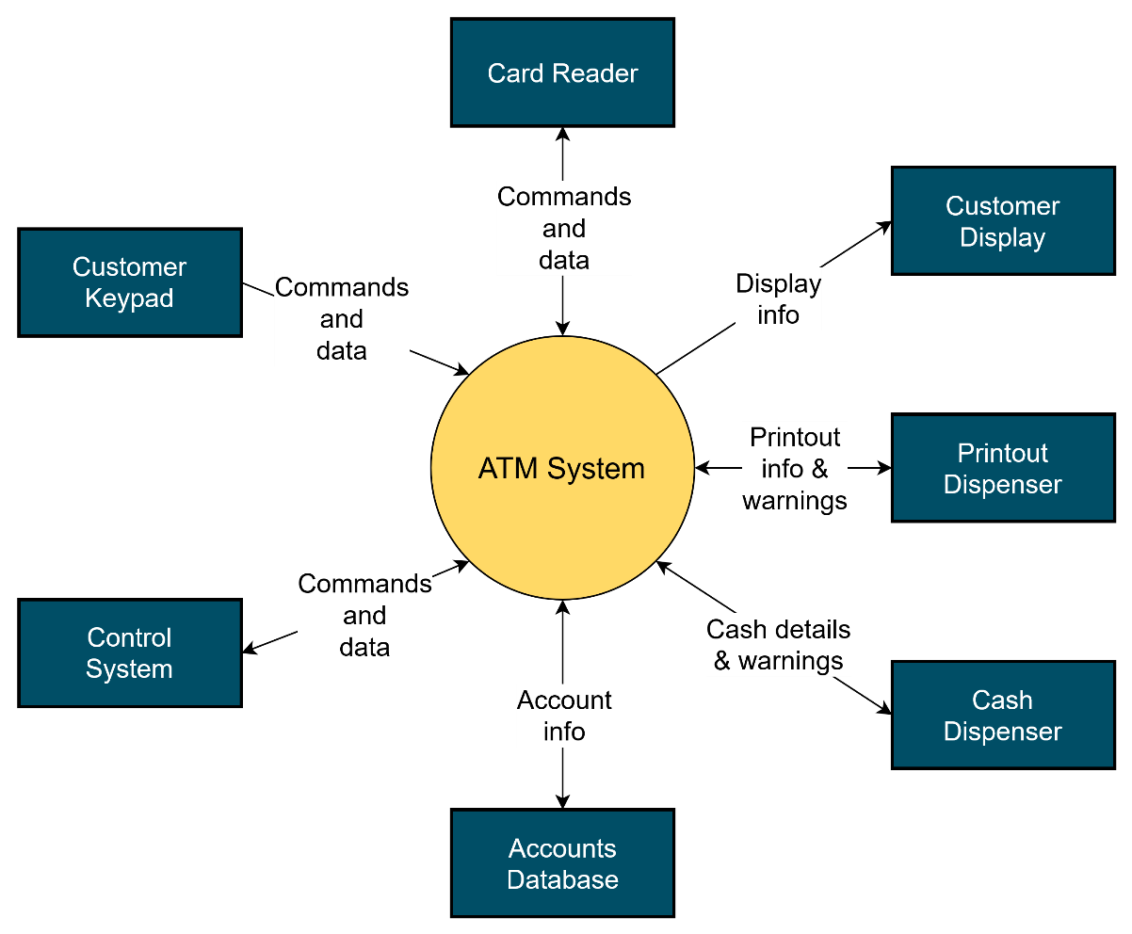
N/A, there is no data at this point in the project since we are only working on hardware.

Level 1 Data Flow Diagram

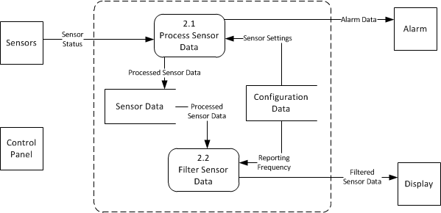
N/A, there is no data at this point in the project since we are only working on hardware.

Level 2 Data Flow Diagram
(Diagram here) …
N/A, there is no data at this point in the project since we are only working on hardware.

Class Model

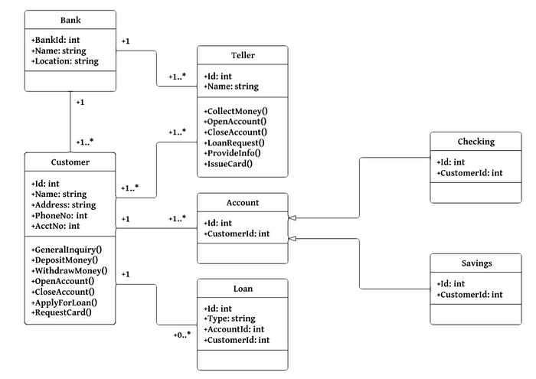
N/A, there is no data at this point in the project since we are only working on hardware.

State Model
(Top-level state chart here)

The substate chart for the Logging In state is shown below.
N/A, there is no data at this point in the project since we are only working on hardware.

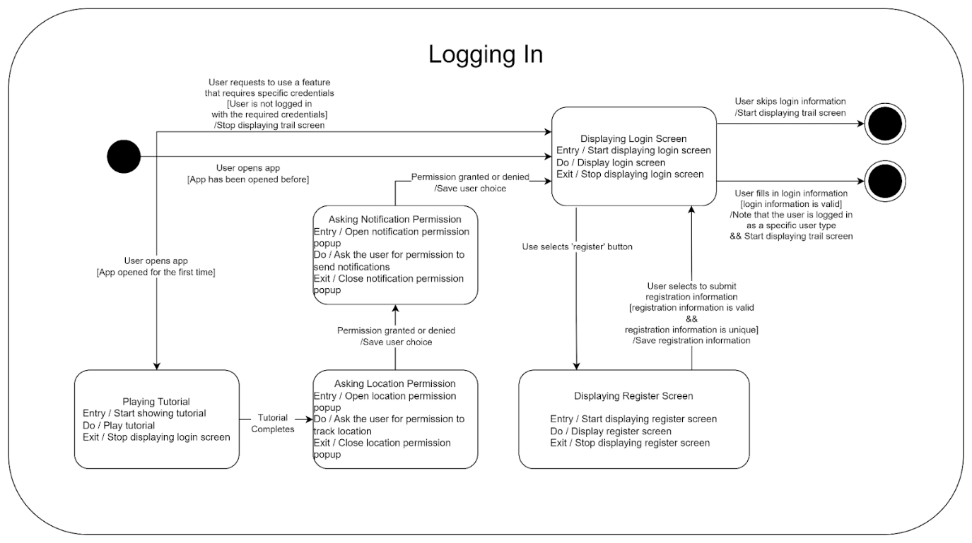

Impact Analysis (10%)
By implementing a more scalable testing platform from simulation to real world testing – we can augment the BID4R lab research outcomes. This charging station can enable a broader adoption of validated resilience training for strategies in the global scale of MAS development and design.
Global Impact: The biologically inspired resilience enables the physical validation of the algorithms for the resilience, so rather than solely relying on the simulation the project strengthens international capabilities in resilient systems designed for autonomy. The BID4R lab’s open-source model promotes a transparent and replicative approach to encourage global academia and collaboration in resilient systems model. This cooperation can disseminate alignments with current global research priorities in satellite and UAV resilience outside of the 2D application of the S.T.A.R.S.
Economic Impact: Resilient MAS reduce downtime, communication loss, and mission risk – which is reduces the cost of saving in aerospace, defense, and the considerable industrial sectors. The proposed system’s ability to assess real-world performance degradation will help optimize fault-tolerant designs thus lowering operational costs for a larger distributed internet of things (IoT) network. Open-source distribution further stimulates the innovation and economic growth by removing proprietary barriers to replication.
Environmental Impact: Improvisation and coordination considering controls within autonomous swarms mitigates the likelihood of satellite collisions and debris generation. This addresses a critical sustainability issue in low Earth orbiting. Laboratory-based experiments also minimize materials wasted and carbon emissions compared to repeated field trials. By refining fault-detection and energy-efficient communication strategies the project supports environmentally responsible system engineering.
Societal Impact: Enhancing the resilience of MASs can lead to safer and more dependable autonomous technologies that assist in disaster response, logistics, and environmental monitoring. The open-source nature of S.T.A.R.S. democratizes access to high-impact impact tools that enable broader participation from universities and research in technologically developed regions. This democratization supports workforce development in autonomous systems and national resilience initiatives.
Public Health/Safety Impact: By experimenting and examining cyber-attacks propagating and containing mechanisms in the swarm the project contributes to improving the cyber security standards for autonomous systems. Insights from this work can enhance human safety around robotic systems. This informs operational safeguards for aerial and ground-based agents. Safety protocols are present and reduce vulnerabilities after the releasing of the platform’s design and documentation for the public usage.

Note: If based on your project, a section would not be applicable, and/or the section would require minimum content, then the grade percentage for that section, will be evenly distributed to other section of the document.

